Tuesday 25th October: 8.30 – 17.30
Certification in Hotel Industry Analytics - Train-the-Trainer Session
Facilitator: Steve Hood (Director of the STR SHARE Center)
In case you have questions or you wish to register for the workshop: SHood@str.com
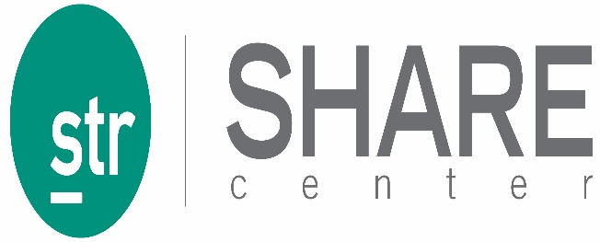
The CHIA is the most popular certification for H&T students, over 6,000 certified. The training covers the following content:
- Hotel Industry Analytical Foundations
- Hotel Math Fundamentals, the metrics used by the Hotel Industry
- Property Level Benchmarking
- Hotel Industry Performance Reports

The session prepares instructors to be able to present the CHIA training to their students. A comprehensive training package is available including PowerPoints, application exercises, supporting materials, quizzes and practice exams. Industry professionals and students are also invited. Space is limited. To hold a seat or for more information, email sharecenter@str.com.
Registration fee:
1. Instructor or professor whether a delegate or not - free, also students who are teaching or research assistants
2. Industry professional - special promotional price of $200 USD. If you have some special friends of the university (alumni, advisory board members or hotels you work with), let me know and we can provide some complimentary seats.
3. Students - $75

